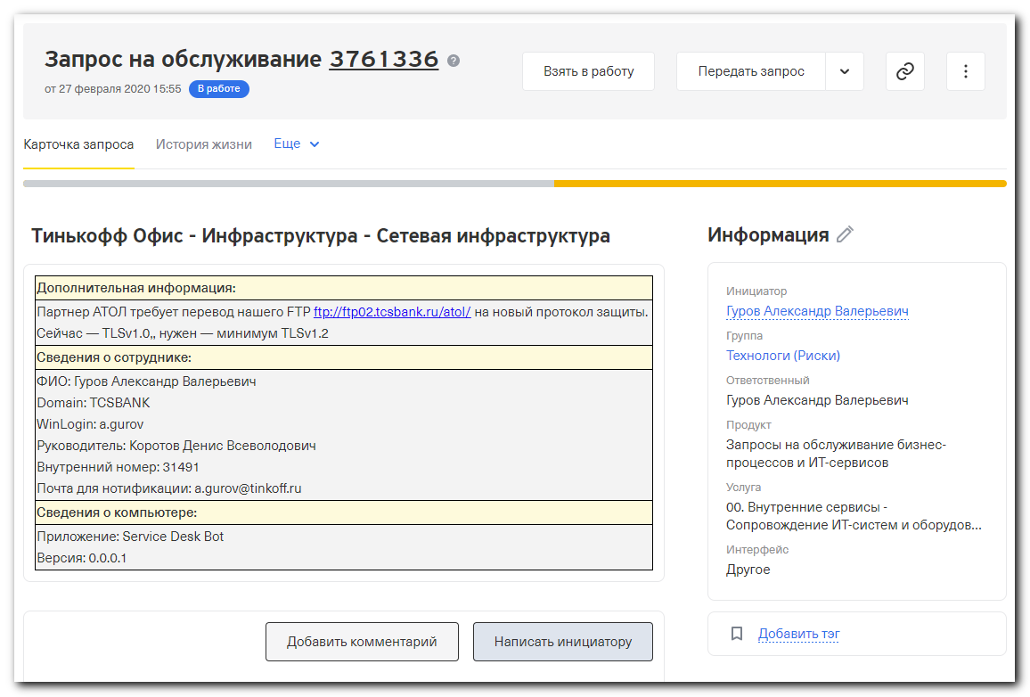
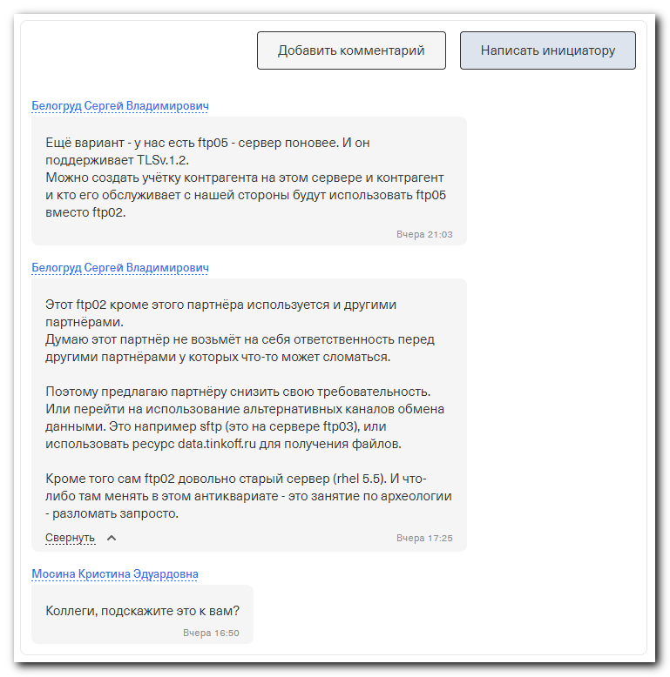

................................................................................

#
# http://lftp.tech/lftp-man.html
#

ftp:ssl-allow (boolean)
if true, try to negotiate SSL connection with FTP server for non-anonymous access.
Default is true. This and other SSL settings are only available if lftp was compiled
with an ssl/tls library.

ftp:ssl-auth (string)
the argument for AUTH command, can be one of SSL, TLS, TLS-P, TLS-C. See RFC4217) for
explanations. By default TLS or SSL will be used, depending on FEAT reply.

ssl:priority (string)
free form priority string for GnuTLS. If built with OpenSSL the understood values are
+ or - followed by SSL3.0, TLS1.0, TLS1.1 or TLS1.2, separated by :. Example:
set ssl:priority "NORMAL:-SSL3.0:-TLS1.0:-TLS1.1:+TLS1.2"

#
# https://access.redhat.com/discussions/2525031
#

#
# Here I can see, that this server use TLS. But we don’t know what version of TLS.
#
[s.belogrud@TCS4357]# lftp -e "set ftp:ssl-allow true; set ftp:ssl-protect-data true ; set passive-mode yes ; set ssl:verify-certificate no ; debug ; ls ; bye" -u 'test','test' ftp05.tcsbank.ru
---- Соединение с ftp05.tcsbank.ru (192.168.5.76), порт 21
<--- 220 (vsFTPd 2.2.2)
---> FEAT
<--- 211-Features:
<--- AUTH SSL
<--- AUTH TLS
<--- EPRT
<--- EPSV
<--- MDTM
<--- PASV
<--- PBSZ
<--- PROT
<--- REST STREAM
<--- SIZE
<--- TVFS
<--- UTF8
<--- 211 End
---> AUTH TLS
<--- 234 Proceed with negotiation.
---> OPTS UTF8 ON
Certificate depth: 2; subject: /C=US/O=DigiCert Inc/OU=www.digicert.com/CN=DigiCert Global Root CA; issuer: /C=US/O=DigiCert Inc/OU=www.digicert.com/CN=DigiCert Global Root CA
Certificate depth: 1; subject: /C=US/O=DigiCert Inc/OU=www.digicert.com/CN=Thawte RSA CA 2018; issuer: /C=US/O=DigiCert Inc/OU=www.digicert.com/CN=DigiCert Global Root CA
Certificate depth: 0; subject: /CN=ftp05.tinkoff.ru; issuer: /C=US/O=DigiCert Inc/OU=www.digicert.com/CN=Thawte RSA CA 2018
WARNING: Certificate verification: subjectAltName does not match «ftp05.tcsbank.ru» (CA:DC:05:F9:71:2A:37:99:6A:CB:E9:96:72:A2:03:4A:4C:5A:7F:EA)
<--- 200 Always in UTF8 mode.
---> USER test
<--- 331 Please specify the password.
---> PASS test
<--- 530 Login incorrect.
---- Закрытие управляющего соединения
ls: Ошибка регистрации: 530 Login incorrect.
[s.belogrud@TCS4357]#

#
# Here we can use special options to force TLS usage and stay only one version of TLS v1.2, that client must use.
# So, in this case we can be sure, that this version works on the server.
#
[s.belogrud@TCS4357]# lftp -e "set ftp:ssl-allow true; set ftp:ssl-protect-data true ; set passive-mode yes ; set ssl:verify-certificate no ; set ftp:ssl-auth TLS ; set ssl:priority NORMAL:-SSL3.0:-TLS1.0:-TLS1.1:+TLS1.2 ; debug ; cd ; bye" -u 'test','test' ftp05.tcsbank.ru
---- Соединение с ftp05.tcsbank.ru (192.168.5.76), порт 21
<--- 220 (vsFTPd 2.2.2)
---> FEAT
<--- 211-Features:
<--- AUTH SSL
<--- AUTH TLS
<--- EPRT
<--- EPSV
<--- MDTM
<--- PASV
<--- PBSZ
<--- PROT
<--- REST STREAM
<--- SIZE
<--- TVFS
<--- UTF8
<--- 211 End
---> AUTH TLS
<--- 234 Proceed with negotiation.
ssl: applied -SSL3.0 option
ssl: applied -TLS1.0 option
ssl: applied -TLS1.1 option
---> OPTS UTF8 ON
Certificate depth: 2; subject: /C=US/O=DigiCert Inc/OU=www.digicert.com/CN=DigiCert Global Root CA; issuer: /C=US/O=DigiCert Inc/OU=www.digicert.com/CN=DigiCert Global Root CA
Certificate depth: 1; subject: /C=US/O=DigiCert Inc/OU=www.digicert.com/CN=Thawte RSA CA 2018; issuer: /C=US/O=DigiCert Inc/OU=www.digicert.com/CN=DigiCert Global Root CA
Certificate depth: 0; subject: /CN=ftp05.tinkoff.ru; issuer: /C=US/O=DigiCert Inc/OU=www.digicert.com/CN=Thawte RSA CA 2018
WARNING: Certificate verification: subjectAltName does not match «ftp05.tcsbank.ru» (CA:DC:05:F9:71:2A:37:99:6A:CB:E9:96:72:A2:03:4A:4C:5A:7F:EA)
<--- 200 Always in UTF8 mode.
---> USER test
<--- 331 Please specify the password.
---> PASS test
<--- 530 Login incorrect.
---- Закрытие управляющего соединения
cd: Ошибка регистрации: 530 Login incorrect.
[s.belogrud@TCS4357]#

#
# To compare with ftp02 server. On the port 21 this server doesn’t support TLS at all.
# And on command FEAT we have not seen that this server support SSL and TLS. And we see only one attempt to login - login with plain ftp sesson.
# Only plain ftp protocol.
#
[s.belogrud@TCS4357]# lftp -e "set ftp:ssl-allow true; set ftp:ssl-protect-data true ; set passive-mode yes ; set ssl:verify-certificate no ; set ftp:ssl-auth TLS ; debug ; cd ; bye" -u 'test','test' ftp02.tcsbank.ru -p 21
---- Соединение с ftp02.tcsbank.ru (192.168.5.58), порт 21
<--- 220 Welcome to FTP service
---> FEAT
<--- 211-Features:
<--- EPRT
<--- EPSV
<--- MDTM
<--- PASV
<--- REST STREAM
<--- SIZE
<--- TVFS
<--- 211 End
---> AUTH TLS
<--- 530 Please login with USER and PASS.
---> USER test
<--- 331 Please specify the password.
---> PASS test
<--- 530 Login incorrect.
cd: Ошибка регистрации: 530 Login incorrect.
---> PWD
<--- 530 Please login with USER and PASS.
---> QUIT
<--- 221 Goodbye.
---- Закрытие управляющего соединения
[s.belogrud@TCS4357]#

#
# Now let’s test TLSv1.2 on ftp02. On port 2121 TLS is working, but not all versions.
# We have to attempts to login. The first unsuccessful attempt is to use connection with TLS. And after unsuccessful the first attempt it used plain ftp connection.
[s.belogrud@TCS4357]# lftp -e "set ftp:ssl-allow true; set ftp:ssl-protect-data true ; set passive-mode yes ; set ssl:verify-certificate no ; set ftp:ssl-auth TLS ; set ssl:priority NORMAL:-SSL3.0:-TLS1.0:-TLS1.1:+TLS1.2 ; debug ; cd ; bye" -u 'test','test' ftp02.tcsbank.ru -p 2121
---- Соединение с ftp02.tcsbank.ru (192.168.5.58), порт 2121
<--- 220 Welcome to FTP service
---> FEAT
<--- 211-Features:
<--- AUTH SSL
<--- AUTH TLS
<--- EPRT
<--- EPSV
<--- MDTM
<--- PASV
<--- PBSZ
<--- PROT
<--- REST STREAM
<--- SIZE
<--- TVFS
<--- 211 End
---> AUTH TLS
<--- 234 Proceed with negotiation.
ssl: applied -SSL3.0 option
ssl: applied -TLS1.0 option
ssl: applied -TLS1.1 option
---> USER test
**** SSL_connect: unsupported protocol
---- Закрытие управляющего соединения
---- Соединение с ftp02.tcsbank.ru (192.168.5.58), порт 2121
<--- 220 Welcome to FTP service
---> FEAT
<--- 211-Features:
<--- AUTH SSL
<--- AUTH TLS
<--- EPRT
<--- EPSV
<--- MDTM
<--- PASV
<--- PBSZ
<--- PROT
<--- REST STREAM
<--- SIZE
<--- TVFS
<--- 211 End
---> USER test
<--- 530 Non-anonymous sessions must use encryption.
cd: Ошибка регистрации: 530 Non-anonymous sessions must use encryption.
---> QUIT
<--- 221 Goodbye.
---- Закрытие управляющего соединения
[s.belogrud@TCS4357]#

#
# Here I’ve turned allow client to use TLSv.1.1. And As we can see - the server ftp02 still not support this version of TLS.
# We have to attempts to login. The first unsuccessful attempt is to use connection with TLS. And after unsuccessful the first attempt it used plain ftp connection.
#
[s.belogrud@TCS4357]# lftp -e "set ftp:ssl-allow true; set ftp:ssl-protect-data true ; set passive-mode yes ; set ssl:verify-certificate no ; set ftp:ssl-auth TLS ; set ssl:priority NORMAL:-SSL3.0:-TLS1.0:+TLS1.1:+TLS1.2 ; debug ; cd ; bye" -u 'test','test' ftp02.tcsbank.ru -p 2121
---- Соединение с ftp02.tcsbank.ru (192.168.5.58), порт 2121
<--- 220 Welcome to FTP service
---> FEAT
<--- 211-Features:
<--- AUTH SSL
<--- AUTH TLS
<--- EPRT
<--- EPSV
<--- MDTM
<--- PASV
<--- PBSZ
<--- PROT
<--- REST STREAM
<--- SIZE
<--- TVFS
<--- 211 End
---> AUTH TLS
<--- 234 Proceed with negotiation.
ssl: applied -SSL3.0 option
ssl: applied -TLS1.0 option
---> USER test
**** SSL_connect: unsupported protocol
---- Закрытие управляющего соединения
---- Соединение с ftp02.tcsbank.ru (192.168.5.58), порт 2121
<--- 220 Welcome to FTP service
---> FEAT
<--- 211-Features:
<--- AUTH SSL
<--- AUTH TLS
<--- EPRT
<--- EPSV
<--- MDTM
<--- PASV
<--- PBSZ
<--- PROT
<--- REST STREAM
<--- SIZE
<--- TVFS
<--- 211 End
---> USER test
<--- 530 Non-anonymous sessions must use encryption.
cd: Ошибка регистрации: 530 Non-anonymous sessions must use encryption.
---> QUIT
<--- 221 Goodbye.
---- Закрытие управляющего соединения
[s.belogrud@TCS4357]#

#
# Now I’ve turned on TLSv.1.0. And this version of TLS this server supports.
# We have only one attempt to login. The first successful attempt is to use connection with TLS.
#
[s.belogrud@TCS4357]# lftp -e "set ftp:ssl-allow true; set ftp:ssl-protect-data true ; set passive-mode yes ; set ssl:verify-certificate no ; set ftp:ssl-auth TLS ; set ssl:priority NORMAL:-SSL3.0:+TLS1.0:+TLS1.1:+TLS1.2 ; debug ; cd ; bye" -u 'test','test' ftp02.tcsbank.ru -p 2121
---- Соединение с ftp02.tcsbank.ru (192.168.5.58), порт 2121
<--- 220 Welcome to FTP service
---> FEAT
<--- 211-Features:
<--- AUTH SSL
<--- AUTH TLS
<--- EPRT
<--- EPSV
<--- MDTM
<--- PASV
<--- PBSZ
<--- PROT
<--- REST STREAM
<--- SIZE
<--- TVFS
<--- 211 End
---> AUTH TLS
<--- 234 Proceed with negotiation.
ssl: applied -SSL3.0 option
---> USER test
Certificate depth: 0; subject: /C=RU/L=Moscow/O=Tinkoff Bank AO/CN=*.tcsbank.ru; issuer: /C=US/O=DigiCert Inc/OU=www.digicert.com/CN=Thawte RSA CA 2018
WARNING: Certificate verification: unable to get local issuer certificate (93:53:1F:81:13:C0:56:B9:B9:50:B6:2C:2E:CF:AE:61:B5:3B:8C:1F)
WARNING: Certificate verification: unable to verify the first certificate (93:53:1F:81:13:C0:56:B9:B9:50:B6:2C:2E:CF:AE:61:B5:3B:8C:1F)
Certificate verification: subjectAltName: «ftp02.tcsbank.ru» matched
<--- 331 Please specify the password.
---> PASS test
<--- 530 Login incorrect.
---- Закрытие управляющего соединения
cd: Ошибка регистрации: 530 Login incorrect.
[s.belogrud@TCS4357]#

#
# Here is for information olny. How looks listing of connection, when I use SSL instead of TLS.
#
[s.belogrud@TCS4357]# lftp -e "set ftp:ssl-allow true; set ftp:ssl-protect-data true ; set passive-mode yes ; set ssl:verify-certificate no ; set ftp:ssl-auth SSL ; set ssl:priority NORMAL:+SSL3.0:+TLS1.0:+TLS1.1:+TLS1.2 ; debug ; cd ; bye" -u 'test','test' ftp02.tcsbank.ru -p 2121
---- Соединение с ftp02.tcsbank.ru (192.168.5.58), порт 2121
<--- 220 Welcome to FTP service
---> FEAT
<--- 211-Features:
<--- AUTH SSL
<--- AUTH TLS
<--- EPRT
<--- EPSV
<--- MDTM
<--- PASV
<--- PBSZ
<--- PROT
<--- REST STREAM
<--- SIZE
<--- TVFS
<--- 211 End
---> AUTH SSL
<--- 234 Proceed with negotiation.
---> USER test
Certificate depth: 0; subject: /C=RU/L=Moscow/O=Tinkoff Bank AO/CN=*.tcsbank.ru; issuer: /C=US/O=DigiCert Inc/OU=www.digicert.com/CN=Thawte RSA CA 2018
WARNING: Certificate verification: unable to get local issuer certificate (93:53:1F:81:13:C0:56:B9:B9:50:B6:2C:2E:CF:AE:61:B5:3B:8C:1F)
WARNING: Certificate verification: unable to verify the first certificate (93:53:1F:81:13:C0:56:B9:B9:50:B6:2C:2E:CF:AE:61:B5:3B:8C:1F)
Certificate verification: subjectAltName: «ftp02.tcsbank.ru» matched
<--- 331 Please specify the password.
---> PASS test
<--- 530 Login incorrect.
---- Закрытие управляющего соединения
cd: Ошибка регистрации: 530 Login incorrect.
[s.belogrud@TCS4357]#

